IT2120 - Probability and Statistics

**IT24103067**

**Khemarathne A.G.S.O.**

Exercise

Instructions: Create a folder in your desktop with your registration number (Eg: ”IT.......”). You need to save the R script file and take screenshots of the command prompt with answers and save it in a word document inside the folder. Save both R script file and word document with your registration number (Eg: ”IT........”). After you finish the exercise, zip the folder and upload the zip file to the submission link.

1. Import the dataset (’Exercise – Lab 05.txt’) into R and store it in a data frame called ”Delivery Times”.

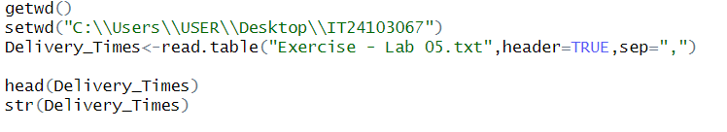

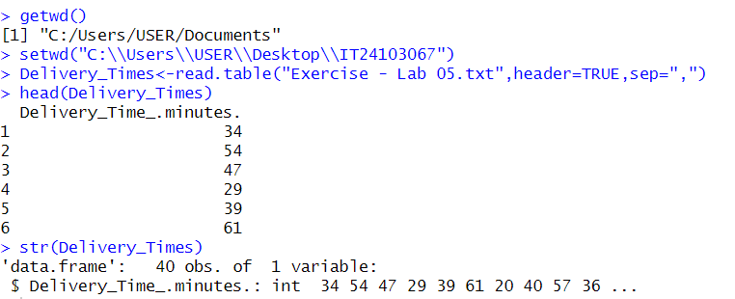

1. Draw a histogram for deliver times using nine class intervals where the lower limit is 20 and upper limit is 70. Use right open intervals.

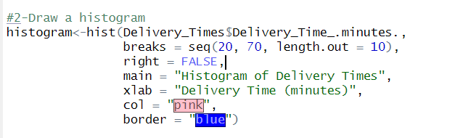

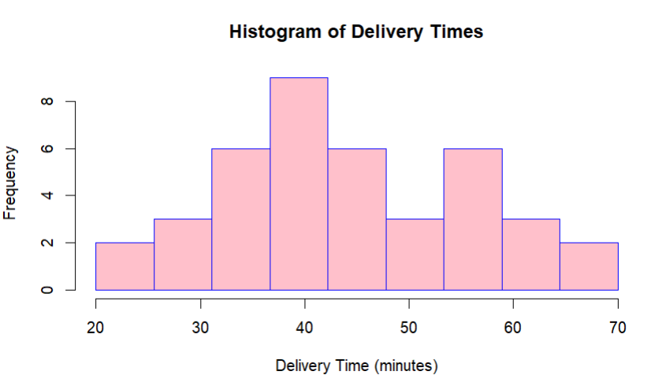

1. Comment on the shape of the distribution.

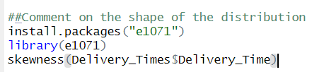



1. Draw a cumulative frequency polygon (ogive) for the data in a separate plot.

